Agenda 455/555 2.13.17 Mon.

* Chapter readings: Chapter 7, 33, 39, 40
* App demos!
* File processing (Text files):

Working the ADB shell

[**http://www.androidcentral.com/android-201-10-basic-terminal-commands-you-should-know**](http://www.androidcentral.com/android-201-10-basic-terminal-commands-you-should-know)

[**http://adbshell.com/commands**](http://adbshell.com/commands) **(See File Manager)**

**CLI tools**

[**https://developer.android.com/studio/command-line/adb.html**](https://developer.android.com/studio/command-line/adb.html)

Importing / Exporting Files – make sure to start app in Debug mode

iMacs-iMac:platform-tools imac$ pwd

/Users/imac/android-sdks/platform-tools

iMacs-iMac:platform-tools imac$ **ls**

NOTICE.txt api etc1tool hprof-conv package.xml sqlite3

adb dmtracedump fastboot lib source.properties systrace

iMacs-iMac:platform-tools imac$ **./adb shell**

generic_x86_64:/ **$ su**

generic_x86_64:/ **# cp /data/data/com.example.mypackage.fileproc/files/hello_file /sdcard**

generic_x86_64:/ **# ! exit**

generic_x86_64:/ **$ exit**

iMacs-iMac:platform-tools imac$ **./adb pull /sdcard/hello_file /Users/imac/Documents**

**[100%] /sdcard/hello_file**

**Sample ‘routed’ Output**

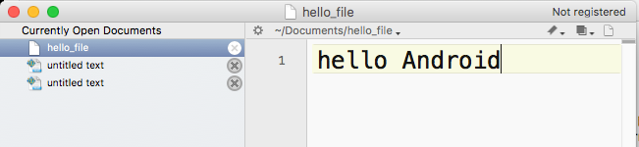

Windows path? – See your SDK Manager

Old school view of DDMS / File Explorer view

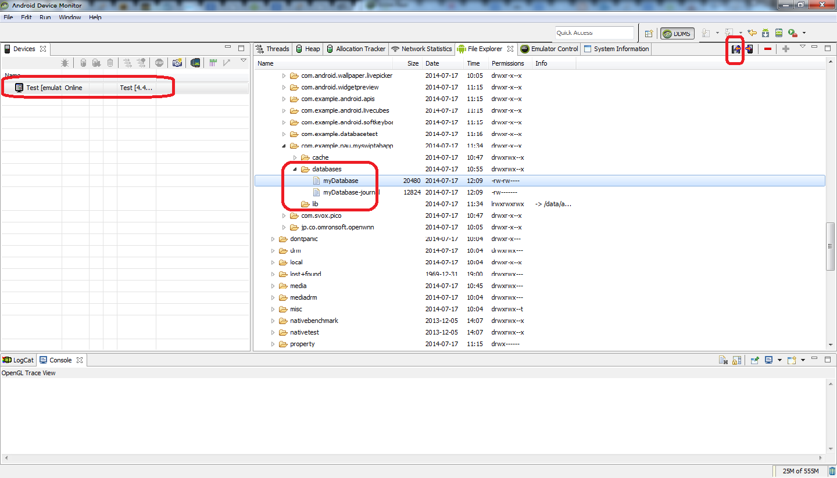

<http://stackoverflow.com/questions/18370219/how-to-use-adb-in-android-studio-to-view-an-sqlite-db>

* Lab 4 run through: Master-Detail views, List View, ArrayAdapter, Intents (Implict vs. Explicit)